**PROJECT-NAME : Myntra**

**DESCRIPTION :**

Being India's largest e-commerce store for fashion and lifestyle products, Myntra aims at providing a hassle free and enjoyable shopping experience to shoppers across the country with the widest range of brands and products on its portal.

**HOME PAGE :**

* Icon bar
* Logo, Nav bar(search button,notifivation,wishlisht,add to bag)
* Header
* Sliders (With images) – top picks, top brands, discounts, sponsers, fashion week sale, new arrivals, promo code sale.

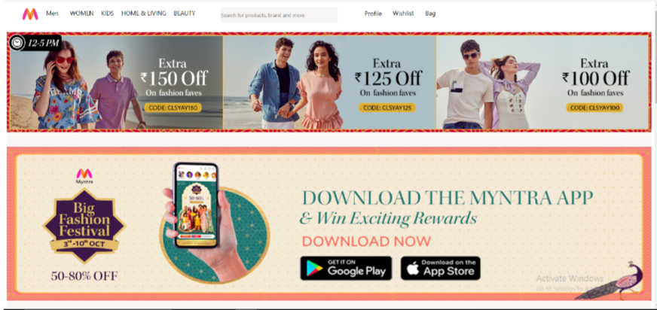

* Footer ( About company, myntra person sliders )
* Footer – Home page, categories, settings, explorer, service desk

**REGISTRATION PAGE :**

* Create account with mail or number
* Sign in to your account
* Proceed with facebook , google , twitter

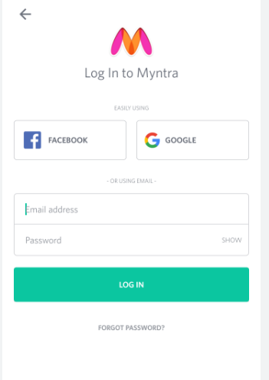

**MAIN PAGE:**

* Filters – brands, price range, size, colors, type, sort, combos, discount
* Selected choices details after filtering
* After selecting particular product its image with slides and video, and its colors, ratings attached coupoun code options.
* Product description – brand, product type, size chart, details, material type, customer responses, customer buyed pictures.
* Related similar products
* Add to bag, wishlist pages

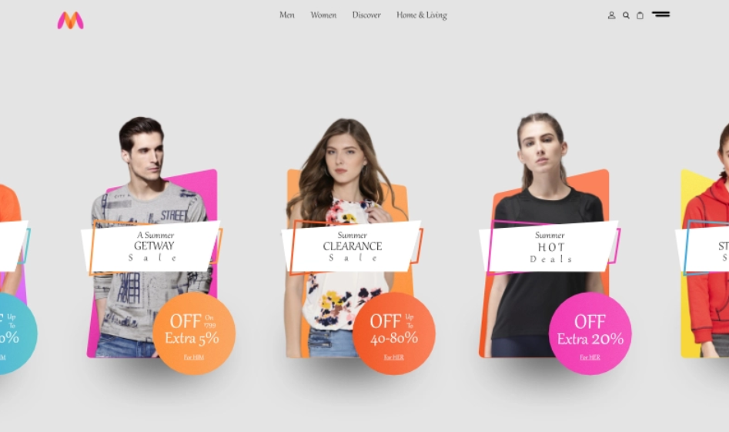

**PAYMENT PAGE :**

* Enter adress dialog box
* Payment method – phonpe, google pay, paytm, debit card details, net banking, cash on delivery

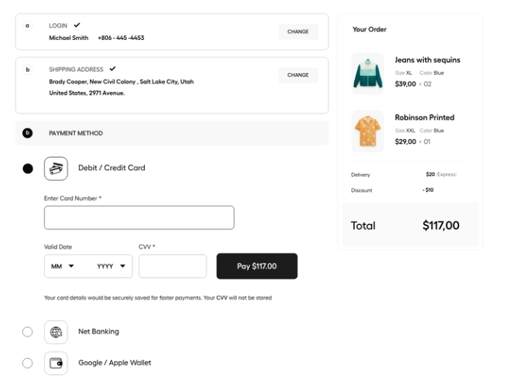

**ORDER PAGE :**

* Track my order – shipping adress and from details, cancel order, refund process.

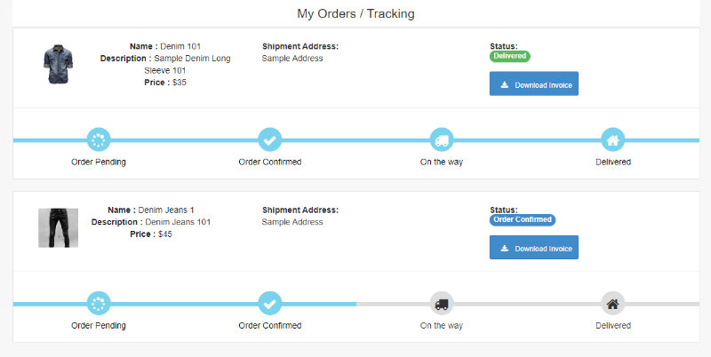

**S.baba fakruddin**